DECLARATION

PROJECT TITLE: TECHNOGAMES

We hereby declare that the project entitled - “TECHNOGAMES”, which is being submitted as a mini project for the 3rd semester in DATA BASE AND WEB LAB in Information Technology department to JAYPEE INSTITUTE OF INFORMATION AND TECHNOLOGY (JIIT) Sec-62, Noida is an authentic record of our genuine work done under the guidance of Mr. ANKIT VIDYARTHI and Mr. VIKAS HASSIJA.

Date:18th December, 2021

Members:

1. Shreya Garg (20104031)

2. Aman Kakkar (20104043)

3. Tanisha Mehrotra (20104035)

4. Samridhi (20104054)

PROBLEM STATEMENT AND OBJECTIVES

We aimed at creating a multi gaming website in which we can play three types of games, TIC TAC TOE, NUMBER GUESSING GAME AND SPEED TYPING GAME. There is also a slideshow about the tutorial of three games to give a better understanding about the games to the viewers. Our application will play an important role for the advancement of apps that are made for entertainment purposes.

We have designed these three games using the web technology of html, css and javascript and we have also used php to provide the authentication for our web page.

Code snippets

LOGIN AND SIGNUP PAGE

<?php

    $host = "localhost";

    $user = "root";

    $password = '';

    $db_name = "login";

    $con = mysqli_connect($host, $user, $password, $db_name);

    if(mysqli_connect_errno()) {

        die("Failed to connect with MySQL: ". mysqli_connect_error());

    }

?>

<?php

$connection = mysqli_connect('localhost', 'root', '', 'login');

if ($connection == false) {

    echo "FAILED";

}

if ($_SERVER['REQUEST_METHOD'] == "POST") {

    $name = $_POST['name'];

    $email = $_POST['email'];

    $pasd = $_POST['password'];

    $sql = "INSERT INTO user(name, email, password) VALUES('$name', '$email', '$pasd' );";

    $utils = mysqli_query($connection, $sql);

    if ($utils == true) {

        echo "Inserted";

    } else {

        echo $connection->error;

    }

    mysqli_close($connection);

}

?>

<!DOCTYPE html>

<head>

    <meta name="viewport" content="width=device-width, initial-scale=1.0">

    <!-- CSS file Included -->

    <link rel="stylesheet" type="text/css" href="login.css">

    <!-- JavaScript file included -->

    <script src="login.js"></script>

    <script>

        function myFunction() {

            alert("Congratulatons!! Signed Up successfully.");

            alert("Now you can login through your credentials.");

        }

    </script>

</head>

<body>

    <div class="form-container sign-in-container">

        <form action="login.php" method="POST">

            <h1>Sign Up</h1>

            <span>Use your account</span>

            <input type="name" placeholder="Name" name="name" required>

            <input type="email" placeholder="Email" name="email" required>

            <input type="password" placeholder="Password" name="password" required>

            <button onclick="myFunction()">SignUp</button>

        </form>

    </div>

    <div class="overlay-container">

        <div class="overlay">

            <div class="overlay-panel overlay-left">

                <h1>Welcome Back!</h1>

                <p>To keep connected with us please login with your personal info</p>

                <button class="ghost" id="signIn">Sign In</button>

            </div>

            <div class="overlay-panel overlay-right">

                <h1>Hey Gamer!</h1>

                <p>Enter your personal details and start journey with us</p>

                <button class="ghost" id="LogIn"><a href="hello.html">Log In</a></button>

            </div>

        </div>

    </div>

</body>

</html>

<?php

session_start();

session_unset();

session_destroy();

echo "SUCCESSFULLY LOGGED OUT";

header("Location: login.php");

?>

<?php

    include('connection.php');

    $username = $_POST['user'];

    $password = $_POST['pass'];

        //to prevent from mysqli injection

        $username = stripcslashes($username);

        $password = stripcslashes($password);

        $username = mysqli_real_escape_string($con, $username);

        $password = mysqli_real_escape_string($con, $password);

        $sql = "select *from user where name = '$username' and password = '$password'";

        $result = mysqli_query($con, $sql);

        $row = mysqli_fetch_array($result, MYSQLI_ASSOC);

        $count = mysqli_num_rows($result);

        if($count == 1){

            echo "<h1><center> Login successful </center></h1>";

        }

        else{

            echo '<script language="javascript">';

            echo 'alert("Login failed. Invalid username or password.")';

            echo '</script>';

        }

?>

<!DOCTYPE html>

<html lang="en">

<head>

    <meta charset="UTF-8">

    <meta http-equiv="X-UA-Compatible" content="IE=edge">

    <meta name="viewport" content="width=device-width, initial-scale=1.0">

    <title>Document</title>

</head>

<body bgcolor="grey">

<form action="index.html" method="POST" align="center">

    <fieldset>

    <legend><h2>Click To Continue</h2></legend>

            <div>

                <button>Continue </button>

            </div>

        </fieldset>

    </form>

</body>

</html>

@import url('https://fonts.googleapis.com/css?family=Montserrat:400,800');

* {

    box-sizing: border-box;

}

body {

    background: black;

    display: flex;

    justify-content: center;

    align-items: center;

    flex-direction: column;

    font-family: 'Montserrat', sans-serif;

    height: 100vh;

    margin: -20px 0 50px;

}

h1 {

    font-weight: bold;

    margin: 0;

}

h2 {

    text-align: center;

}

p {

    font-size: 14px;

    font-weight: 100;

    line-height: 20px;

    letter-spacing: 0.5px;

    margin: 20px 0 30px;

}

span {

    font-size: 12px;

}

a {

    color: #333;

    font-size: 14px;

    text-decoration: none;

    margin: 15px 0;

}

button {

    border-radius: 20px;

    border: 1px solid #FF4B2B;

    background-color: #FF4B2B;

    color: #FFFFFF;

    font-size: 12px;

    font-weight: bold;

    padding: 12px 45px;

    letter-spacing: 1px;

    text-transform: uppercase;

    transition: transform 80ms ease-in;

}

button:active {

    transform: scale(0.95);

}

button:focus {

    outline: none;

}

button.ghost {

    background-color: transparent;

    border-color: #FFFFFF;

}

form {

    background-color: #FFFFFF;

    display: flex;

    align-items: center;

    justify-content: center;

    flex-direction: column;

    padding: 0 50px;

    height: 100%;

    text-align: center;

}

input {

    background-color: #eee;

    border: none;

    padding: 12px 15px;

    margin: 8px 0;

    width: 100%;

}

.container {

    background-color: #fff;

    border-radius: 10px;

    box-shadow: 0 14px 28px rgba(0,0,0,0.25),

            0 10px 10px rgba(0,0,0,0.22);

    position: relative;

    overflow: hidden;

    width: 768px;

    max-width: 100%;

    min-height: 480px;

}

.form-container {

    position: absolute;

    top: 0;

    height: 100%;

    transition: all 0.6s ease-in-out;

}

.sign-in-container {

    left: 0;

    width: 50%;

    z-index: 2;

}

.container.right-panel-active .sign-in-container {

    transform: translateX(100%);

}

.sign-up-container {

    left: 0;

    width: 50%;

    opacity: 0;

    z-index: 1;

}

.container.right-panel-active .sign-up-container {

    transform: translateX(100%);

    opacity: 1;

    z-index: 5;

    animation: show 0.6s;

}

@keyframes show {

    0%, 49.99% {

        opacity: 0;

        z-index: 1;

    }

    50%, 100% {

        opacity: 1;

        z-index: 5;

    }

}

.overlay-container {

    position: absolute;

    top: 0;

    left: 50%;

    width: 50%;

    height: 100%;

    overflow: hidden;

    transition: transform 0.6s ease-in-out;

    z-index: 100;

}

.container.right-panel-active .overlay-container{

    transform: translateX(-100%);

}

.overlay {

    background: #FF416C;

    background: -webkit-linear-gradient(to right, #FF4B2B, #FF416C);

    background: linear-gradient(to right, #FF4B2B, #FF416C);

    background-repeat: no-repeat;

    background-size: cover;

    background-position: 0 0;

    color: #FFFFFF;

    position: relative;

    left: -100%;

    height: 100%;

    width: 200%;

    transform: translateX(0);

    transition: transform 0.6s ease-in-out;

}

.container.right-panel-active .overlay {

    transform: translateX(50%);

}

.overlay-panel {

    position: absolute;

    display: flex;

    align-items: center;

    justify-content: center;

    flex-direction: column;

    padding: 0 40px;

    text-align: center;

    top: 0;

    height: 100%;

    width: 50%;

    transform: translateX(0);

    transition: transform 0.6s ease-in-out;

}

.overlay-left {

    transform: translateX(-20%);

}

.container.right-panel-active .overlay-left {

    transform: translateX(0);

}

.overlay-right {

    right: 0;

    transform: translateX(0);

}

.container.right-panel-active .overlay-right {

    transform: translateX(20%);

}

.social-container {

    margin: 20px 0;

}

.social-container a {

    border: 1px solid #DDDDDD;

    border-radius: 50%;

    display: inline-flex;

    justify-content: center;

    align-items: center;

    margin: 0 5px;

    height: 40px;

    width: 40px;

}

footer {

    background-color: #222;

    color: #fff;

    font-size: 14px;

    bottom: 0;

    position: fixed;

    left: 0;

    right: 0;

    text-align: center;

    z-index: 999;

}

footer p {

    margin: 10px 0;

}

footer i {

    color: red;

}

footer a {

    color: #3c97bf;

    text-decoration: none;

}

const signUpButton = document.getElementById('signUp');

const signInButton = document.getElementById('signIn');

const container = document.getElementById('container');

signUpButton.addEventListener('click', () => {

    container.classList.add("right-panel-active");

});

signInButton.addEventListener('click', () => {

    container.classList.remove("right-panel-active");

});

body{

    background-image: url("bg.jpeg");

    background: blueviolet;

}

#frm{

    color: white;

    border: solid rgb(0, 0, 0) 1px;

    width:25%;

    border-radius: 2px;

    margin: 120px auto;

    background: rgb(51, 42, 42);

    padding: 50px;

}

#btn{

    color: white;

    background: red;

    padding: 7px;

    margin-left: 45%;

}

MAIN PAGE AND SLIDESHOW

@importurl('https://fonts.googleapis.com/css2?family=Russo+One&display=swap');

html,

body {

    height: 100%;

    display: flex;

    align-items: flex-start;

    justify-content: center;

    background-color: black;

}

.box {

    display: flex;

}

.box .inner {

    width: 250px;

    height: 150px;

    line-height: 120px;

    font-size: 3em;

    font-weight: bold;

    white-space: nowrap;

    overflow: hidden;

     font-family: 'Russo One', sans-serif;;

}

.box .inner:first-child {

    background-color: rgba(255, 0, 0, 0.658);

    color: black;

    transform-origin: right;

    transform: perspective(100px) rotateY(-15deg);

}

.box .inner:last-child {

    background-color: indianred;

    color: antiquewhite;

    transform-origin: left;

    transform: perspective(100px) rotateY(15deg);

}

.box .inner span {

    position: absolute;

    animation: marquee 5s linear infinite;

}

.box .inner:first-child span {

    animation-delay: 2.5s;

    left: -160%;

}

@keyframes marquee {

    from {

        left: 100%;

    }

    to {

        left: -100%;

    }

}

.user a{

    position: absolute;

    top:7%;

    left:75%;

    font-size: 1.5em;

}

.logout a{

    position: absolute;

    top:7%;

    left:85%;

    font-size: 1.5em;

}

* {box-sizing:border-box}

/* Slideshow container */

.slideshow-container {

  max-width: 1000px;

  position: absolute;

  top:30%;

}

/* Hide the images by default */

.mySlides {

  display: none;

}

/* Next & previous buttons */

.prev, .next {

  cursor: pointer;

  position: absolute;

  top: 50%;

  width: auto;

  margin-top: -22px;

  padding: 16px;

  color: white;

  font-weight: bold;

  font-size: 18px;

  transition: 0.6s ease;

  border-radius: 0 3px 3px 0;

  user-select: none;

}

/* Position the "next button" to the right */

.next {

  right: 0;

  border-radius: 3px 0 0 3px;

}

/* On hover, add a black background color with a little bit see-through */

.prev:hover, .next:hover {

  background-color: rgba(0,0,0,0.8);

}

/* Number text (1/3 etc) */

.numbertext {

  color: #f2f2f2;

  font-size: 12px;

  padding: 8px 12px;

  position: absolute;

  top: 0;

}

/* Fading animation */

.fade {

  -webkit-animation-name: fade;

  -webkit-animation-duration: 0.5s;

  animation-name: fade;

  animation-duration: 1.5s;

}

@-webkit-keyframes fade {

  from {opacity: .4}

  to {opacity: 1}

}

@keyframes fade {

  from {opacity: .4}

  to {opacity: 1}

}

.flip-card1 {

    background-color: transparent;

    width: 300px;

    height: 200px;

    perspective: 1000px; /* Remove this if you don't want the 3D effect */

    position: absolute;

    top: 140%;

    right:70%;

  }

  /* This container is needed to position the front and back side */

  .flip-card-inner1 {

    position: relative;

    width: 100%;

    height: 100%;

    text-align: center;

    transition: transform 0.8s;

    transform-style: preserve-3d;

  }

  /* Do an horizontal flip when you move the mouse over the flip box container */

  .flip-card1:hover .flip-card-inner1 {

    transform: rotateY(180deg);

  }

  /* Position the front and back side */

  .flip-card-front1, .flip-card-back1 {

    position: absolute;

    width: 100%;

    height: 100%;

    -webkit-backface-visibility: hidden; /* Safari */

    backface-visibility: hidden;

  }

  /* Style the front side (fallback if image is missing) */

  .flip-card-front1 {

    background-color: #bbb;

    color: black;

  }

  /* Style the back side */

  .flip-card-back1 {

    background-color: red;

    color: white;

    transform: rotateY(180deg);

  }

  .flip-card-back1 a{

      text-decoration: none;

        color:white;

  }

  .flip-card2 {

    background-color: transparent;

    width: 300px;

    height: 200px;

    perspective: 1000px; /* Remove this if you don't want the 3D effect */

    position: absolute;

    top: 140%;

    left:40%;

  }

  /* This container is needed to position the front and back side */

  .flip-card-inner2 {

    position: relative;

    width: 100%;

    height: 100%;

    text-align: center;

    transition: transform 0.8s;

    transform-style: preserve-3d;

  }

  /* Do an horizontal flip when you move the mouse over the flip box container */

  .flip-card2:hover .flip-card-inner2 {

    transform: rotateY(180deg);

  }

  /* Position the front and back side */

  .flip-card-front2, .flip-card-back2 {

    position: absolute;

    width: 100%;

    height: 100%;

    -webkit-backface-visibility: hidden; /* Safari */

    backface-visibility: hidden;

  }

  /* Style the front side (fallback if image is missing) */

  .flip-card-front2 {

    background-color: #bbb;

    color: black;

  }

  /* Style the back side */

  .flip-card-back2 {

    background-color: red;

    color: white;

    transform: rotateY(180deg);

  }

  .flip-card-back2 a{

      text-decoration: none;

        color:white;

  }

  .flip-card3 {

    background-color: transparent;

    width: 300px;

    height: 200px;

    perspective: 1000px; /* Remove this if you don't want the 3D effect */

    position: absolute;

    top: 140%;

    left:70%;

  }

  /* This container is needed to position the front and back side */

  .flip-card-inner3 {

    position: relative;

    width: 100%;

    height: 100%;

    text-align: center;

    transition: transform 0.8s;

    transform-style: preserve-3d;

  }

  /* Do an horizontal flip when you move the mouse over the flip box container */

  .flip-card3:hover .flip-card-inner3 {

    transform: rotateY(180deg);

  }

  /* Position the front and back side */

  .flip-card-front3, .flip-card-back3 {

    position: absolute;

    width: 100%;

    height: 100%;

    -webkit-backface-visibility: hidden; /* Safari */

    backface-visibility: hidden;

  }

  /* Style the front side (fallback if image is missing) */

  .flip-card-front3 {

    background-color: #bbb;

    color: black;

  }

  /* Style the back side */

  .flip-card-back3 {

    background-color: red;

    color: white;

    transform: rotateY(180deg);

  }

  .flip-card-back3 a{

      text-decoration: none;

        color:white;

  }

var slideIndex = 1;

showSlides(slideIndex);

// Next/previous controls

function plusSlides(n) {

  showSlides(slideIndex += n);

}

// Thumbnail image controls

function currentSlide(n) {

  showSlides(slideIndex = n);

}

function showSlides(n) {

  var i;

  var slides = document.getElementsByClassName("mySlides");

  var dots = document.getElementsByClassName("dot");

  if (n > slides.length) {slideIndex = 1}

  if (n < 1) {slideIndex = slides.length}

  for (i = 0; i < slides.length; i++) {

      slides[i].style.display = "none";

  }

  for (i = 0; i < dots.length; i++) {

      dots[i].className = dots[i].className.replace(" active", "");

  }

  slides[slideIndex-1].style.display = "block";

  dots[slideIndex-1].className += " active";

}

TIC TAC TOE

* {

    margin: 0;

    padding: 0;

    box-sizing: border-box;

}

body {

    background-color: #576574;

    overflow: -moz-hidden-unscrollable;

    height: 100vh;

}

.NavBar--Main {

    display: flex;

    padding: 40px;

    color: white;

    display: flex;

    font-size: 20px;

    font-family: 'Montserrat', sans-serif;

    justify-content: space-between;

    box-shadow: 0px 2px 5px black;

}

.Score--Bar {

    display: flex;

    padding-left: 40px;

    padding-right: 40px;

    color: white;

    display: flex;

    font-size: 20px;

    font-family: 'Montserrat', sans-serif;

    justify-content: space-between;

}

.Game-Outer {

    height: 300px;

    width: 300px;

    margin: auto;

    margin-top: 15vh;

    display: absolute;

}

.Game-Board {

    height: 300px;

    width: 300px;

    display: grid;

    grid-template-columns: auto auto auto;

}

#line1 {

    display: none;

    position: absolute;

    height: 10px;

    width: 280px;

    background: #222f3e;

    border: 0px;

    border-radius: 10px;

    margin-left: 10px;

    margin-top: 50px;

}

@keyframes draw_line {

    from {

        width: 0px;

    }

    to {

        width: 280px;

    }

}

#line2 {

    display: none;

    position: absolute;

    width: 280px;

    height: 10px;

    background: #222f3e;

    border: 0px;

    border-radius: 10px;

    margin-left: 10px;

    margin-top: 150px;

}

#line3 {

    display: none;

    position: absolute;

    width: 280px;

    height: 10px;

    background: #222f3e;

    border: 0px;

    border-radius: 10px;

    margin-left: 10px;

    margin-top: 250px;

}

#line4 {

    display: none;

    position: absolute;

    width: 280px;

    height: 10px;

    transform: rotate(90deg);

    transform-origin: 0% 0%;

    background: #222f3e;

    border: 0px;

    border-radius: 10px;

    margin-left: 50px;

    margin-top: 15px;

}

#line5 {

    display: none;

    position: absolute;

    width: 280px;

    height: 10px;

    transform: rotate(90deg);

    transform-origin: 0% 0%;

    background: #222f3e;

    border: 0px;

    border-radius: 10px;

    margin-left: 150px;

    margin-top: 15px;

}

#line6 {

    display: none;

    position: absolute;

    width: 280px;

    height: 10px;

    transform: rotate(90deg);

    transform-origin: 0% 0%;

    background: #222f3e;

    border: 0px;

    border-radius: 10px;

    margin-left: 250px;

    margin-top: 15px;

}

#line7 {

    display: none;

    position: absolute;

    width: 300px;

    height: 10px;

    transform: rotate(45deg);

    transform-origin: 0% 0%;

    background: #222f3e;

    border: 0px;

    border-radius: 10px;

    margin-left: 50px;

    margin-top: 45px;

}

#line8 {

    display: none;

    position: absolute;

    width: 300px;

    height: 10px;

    transform: rotate(-45deg);

    transform-origin: 100% 0%;

    background: #222f3e;

    border: 0px;

    border-radius: 10px;

    margin-left: -50px;

    margin-top: 50px;

}

.Computer-Score {

    text-align: center;

    font-size: 20px;

    font-family: 'Montserrat', sans-serif;

    color: white;

}

h1 {

    font-size: 80px;

    font-family: 'Montserrat', sans-serif;

    color: white;

}

.Box-1 {

    text-align: center;

    border: 1px solid white;

    border-top-style: none;

    border-right-style: solid;

    border-bottom-style: solid;

    border-left-style: none;

    height: 100px;

    width: 100px;

    grid-row-start: 1;

}

.Box-2 {

    height: 100px;

    width: 100px;

    text-align: center;

    border: 1px solid white;

    border-top-style: none;

    border-right-style: solid;

    border-bottom-style: solid;

    border-left-style: solid;

}

.Box-3 {

    height: 100px;

    width: 100px;

    text-align: center;

    border: 1px solid white;

    border-top-style: none;

    border-right-style: none;

    border-bottom-style: solid;

    border-left-style: solid;

}

.Box-4 {

    height: 100px;

    width: 100px;

    text-align: center;

    border: 1px solid white;

    border-top-style: none;

    border-right-style: solid;

    border-bottom-style: solid;

    border-left-style: none;

}

.Box-5 {

    height: 100px;

    width: 100px;

    text-align: center;

    border-top-style: none;

    border-right-style: solid;

    border-bottom-style: solid;

    border-left-style: none;

    border: 1px solid white;

}

.Box-6 {

    height: 100px;

    width: 100px;

    text-align: center;

    border: 1px solid white;

    border-top-style: solid;

    border-right-style: none;

    border-bottom-style: solid;

    border-left-style: solid;

}

.Box-7 {

    height: 100px;

    width: 100px;

    text-align: center;

    border: 1px solid white;

    border-top-style: solid;

    border-right-style: solid;

    border-bottom-style: none;

    border-left-style: none;

}

.Box-8 {

    height: 100px;

    width: 100px;

    text-align: center;

    border: 1px solid white;

    border-top-style: solid;

    border-right-style: solid;

    border-bottom-style: none;

    border-left-style: solid;

}

.Box-9 {

    text-align: center;

    height: 100px;

    width: 100px;

    border: 1px solid white;

    border-top-style: solid;

    border-right-style: none;

    border-bottom-style: none;

    border-left-style: solid;

}

.occupy_full {

    display: flex;

    justify-content: center;

}

#Restart {

    border: 0px;

    border-radius: 8px;

    margin-left: 50vw;

    margin-right: 50vw;

    padding: 10px;

    background-color: #222f3e;

    color: white;

    display: none;

}

#result {

    position: absolute;

    top: 150px;

    width: 190px;

    padding: 10px;

    background-color: white;

    font-size: 16px;

    border-radius: 0px 8px 8px 0px;

    font-family: 'Montserrat', sans-serif;

    color: black;

    display: none;

}

@keyframes display_result {

    from {

        left: -190px;

    }

    to {

        left: 0px;

    }

}

@media screen and (max-width: 600px) {

    .NavBar--Main {

        padding: 20px;

    }

    .Score--Bar {

        padding-left: 20px;

        padding-right: 20px;

    }

}

const box1 = document.getElementById('Box-1');

const box2 = document.getElementById('Box-2');

const box3 = document.getElementById('Box-3');

const box4 = document.getElementById('Box-4');

const box5 = document.getElementById('Box-5');

const box6 = document.getElementById('Box-6');

const box7 = document.getElementById('Box-7');

const box8 = document.getElementById('Box-8');

const box9 = document.getElementById('Box-9');

const line1 = document.getElementById('line1').style;

const line2 = document.getElementById('line2').style;

const line3 = document.getElementById('line3').style;

const line4 = document.getElementById('line4').style;

const line5 = document.getElementById('line5').style;

const line6 = document.getElementById('line6').style;

const line7 = document.getElementById('line7').style;

const line8 = document.getElementById('line8').style;

let game_played = document.getElementById('Games-Played');

let score_bar = document.getElementsByClassName('Score--Bar');

let USER = document.getElementById('user');

let COMP = document.getElementById('comp');

let restart = document.getElementById('Restart');

let result = document.getElementById('result');

console.log(restart.innerHTML)

let MatchCompleted = false;

let nog = 0;

let user_turn = true;

let comp_turn = true;

let comp = 0;

let user = 0;

var num;

function box_1() {

    if (user_turn) {

        if (box1.innerHTML != "X" &&

            box1.innerHTML != "O") {

            user_turn = false;

            box1.innerHTML = "X";

            checkMatch();

            computer_go();

        }

    }

}

function box_2() {

    if (user_turn) {

        if (box2.innerHTML != "X" &&

            box2.innerHTML != "O") {

            user_turn = false;

            box2.innerHTML = "X";

            checkMatch();

            computer_go();

        }

    }

}

function box_3() {

    if (user_turn) {

        if (box3.innerHTML != "X" &&

            box3.innerHTML != "O") {

            user_turn = false;

            box3.innerHTML = "X";

            checkMatch();

            computer_go();

        }

    }

}

function box_4() {

    if (user_turn) {

        if (box4.innerHTML != "X" &&

            box4.innerHTML != "O") {

            user_turn = false;

            box4.innerHTML = "X";

            checkMatch();

            computer_go();

        }

    }

}

function box_5() {

    if (user_turn) {

        if (box5.innerHTML != "X" &&

            box5.innerHTML != "O") {

            user_turn = false;

            box5.innerHTML = "X";

            checkMatch();

            computer_go();

        }

    }

}

function box_6() {

    if (user_turn) {

        if (box6.innerHTML != "X" &&

            box6.innerHTML != "O") {

            user_turn = false;

            box6.innerHTML = "X";

            checkMatch();

            computer_go();

        }

    }

}

function box_7() {

    if (user_turn) {

        if (box7.innerHTML != "X" &&

            box7.innerHTML != "O") {

            user_turn = false;

            box7.innerHTML = "X";

            checkMatch();

            computer_go();

        }

    }

}

function box_8() {

    if (user_turn) {

        if (box8.innerHTML != "X" &&

            box8.innerHTML != "O") {

            user_turn = false;

            box8.innerHTML = "X";

            checkMatch();

            computer_go();

        }

    }

}

function box_9() {

    if (user_turn) {

        if (box9.innerHTML != "X" &&

            box9.innerHTML != "O") {

            user_turn = false;

            box9.innerHTML = "X";

            checkMatch();

            computer_go();

        }

    }

}

function computer_go() {

    var num = Math.floor(Math.random() * 9) + 1

    if (comp_turn) {

        if (num === 1) {

            if (box1.innerHTML != "X" && box1.innerHTML != "O") {

                box1.innerHTML = "O"

                user_turn = true;

                checkMatch();

            } else {

                if (box1.innerHTML.length == 1 &&

                    box2.innerHTML.length == 1 &&

                    box3.innerHTML.length == 1 &&

                    box4.innerHTML.length == 1 &&

                    box5.innerHTML.length == 1 &&

                    box6.innerHTML.length == 1 &&

                    box7.innerHTML.length == 1 &&

                    box8.innerHTML.length == 1 &&

                    box9.innerHTML.length == 1) {} else {

                    computer_go();

                }

            }

        }

        if (num === 2) {

            if (box2.innerHTML != "X" &&

                box2.innerHTML != "O") {

                box2.innerHTML = "O"

                user_turn = true;

                checkMatch();

            } else {

                if (box1.innerHTML.length == 1 &&

                    box2.innerHTML.length == 1 &&

                    box3.innerHTML.length == 1 &&

                    box4.innerHTML.length == 1 &&

                    box5.innerHTML.length == 1 &&

                    box6.innerHTML.length == 1 &&

                    box7.innerHTML.length == 1 &&

                    box8.innerHTML.length == 1 &&

                    box9.innerHTML.length == 1) {} else {

                    computer_go();

                }

            }

        }

        if (num === 3) {

            if (box3.innerHTML != "X" &&

                box3.innerHTML != "O") {

                box3.innerHTML = "O"

                user_turn = true;

                checkMatch();

            } else {

                if (box1.innerHTML.length == 1 &&

                    box2.innerHTML.length == 1 &&

                    box3.innerHTML.length == 1 &&

                    box4.innerHTML.length == 1 &&

                    box5.innerHTML.length == 1 &&

                    box6.innerHTML.length == 1 &&

                    box7.innerHTML.length == 1 &&

                    box8.innerHTML.length == 1 &&

                    box9.innerHTML.length == 1) {} else {

                    computer_go();

                }

            }

        }

        if (num === 4) {

            if (box4.innerHTML != "X" &&

                box4.innerHTML != "O") {

                box4.innerHTML = "O"

                user_turn = true;

                checkMatch();

            } else {

                if (box1.innerHTML.length == 1 &&

                    box2.innerHTML.length == 1 &&

                    box3.innerHTML.length == 1 &&

                    box4.innerHTML.length == 1 &&

                    box5.innerHTML.length == 1 &&

                    box6.innerHTML.length == 1 &&

                    box7.innerHTML.length == 1 &&

                    box8.innerHTML.length == 1 &&

                    box9.innerHTML.length == 1) {} else {

                    computer_go();

                }

            }

        }

        if (num === 5) {

            if (box5.innerHTML != "X" &&

                box5.innerHTML != "O") {

                box5.innerHTML = "O"

                user_turn = true;

                checkMatch();

            } else {

                if (box1.innerHTML.length == 1 &&

                    box2.innerHTML.length == 1 &&

                    box3.innerHTML.length == 1 &&

                    box4.innerHTML.length == 1 &&

                    box5.innerHTML.length == 1 &&

                    box6.innerHTML.length == 1 &&

                    box7.innerHTML.length == 1 &&

                    box8.innerHTML.length == 1 &&

                    box9.innerHTML.length == 1) {} else {

                    computer_go();

                }

            }

        }

        if (num === 6) {

            if (box6.innerHTML != "X" &&

                box6.innerHTML != "O") {

                box6.innerHTML = "O"

                user_turn = true;

                checkMatch();

            } else {

                if (box1.innerHTML.length == 1 &&

                    box2.innerHTML.length == 1 &&

                    box3.innerHTML.length == 1 &&

                    box4.innerHTML.length == 1 &&

                    box5.innerHTML.length == 1 &&

                    box6.innerHTML.length == 1 &&

                    box7.innerHTML.length == 1 &&

                    box8.innerHTML.length == 1 &&

                    box9.innerHTML.length == 1) {} else {

                    computer_go();

                }

            }

        }

        if (num === 7) {

            if (box7.innerHTML != "X" &&

                box7.innerHTML != "O") {

                box7.innerHTML = "O"

                user_turn = true;

                checkMatch();

            } else {

                if (box1.innerHTML.length == 1 &&

                    box2.innerHTML.length == 1 &&

                    box3.innerHTML.length == 1 &&

                    box4.innerHTML.length == 1 &&

                    box5.innerHTML.length == 1 &&

                    box6.innerHTML.length == 1 &&

                    box7.innerHTML.length == 1 &&

                    box8.innerHTML.length == 1 &&

                    box9.innerHTML.length == 1) {} else {

                    computer_go();

                }

            }

        }

        if (num === 8) {

            if (box8.innerHTML != "X" &&

                box8.innerHTML != "O") {

                box8.innerHTML = "O"

                user_turn = true;

                checkMatch();

            } else {

                if (box1.innerHTML.length == 1 &&

                    box2.innerHTML.length == 1 &&

                    box3.innerHTML.length == 1 &&

                    box4.innerHTML.length == 1 &&

                    box5.innerHTML.length == 1 &&

                    box6.innerHTML.length == 1 &&

                    box7.innerHTML.length == 1 &&

                    box8.innerHTML.length == 1 &&

                    box9.innerHTML.length == 1) {} else {

                    computer_go();

                }

            }

        }

        if (num === 9) {

            if (box9.innerHTML != "X" &&

                box9.innerHTML != "O") {

                box9.innerHTML = "O"

                user_turn = true;

                checkMatch();

            } else {

                if (box1.innerHTML.length == 1 &&

                    box2.innerHTML.length == 1 &&

                    box3.innerHTML.length == 1 &&

                    box4.innerHTML.length == 1 &&

                    box5.innerHTML.length == 1 &&

                    box6.innerHTML.length == 1 &&

                    box7.innerHTML.length == 1 &&

                    box8.innerHTML.length == 1 &&

                    box9.innerHTML.length == 1) {} else {

                    computer_go();

                }

            }

        }

    }

}

function checkMatch() {

    if (box1.innerHTML.length == 1 &&

        box2.innerHTML.length == 1 &&

        box3.innerHTML.length == 1 &&

        box4.innerHTML.length == 1 &&

        box5.innerHTML.length == 1 &&

        box6.innerHTML.length == 1 &&

        box7.innerHTML.length == 1 &&

        box8.innerHTML.length == 1 &&

        box9.innerHTML.length == 1) {

        //Horizontal lines

        if (box1.innerHTML == "X" && box2.innerHTML == "X" && box3.innerHTML == "X") {

            user += 1;

            result.innerHTML = "User won the game";

            line1.display = "flex";

            line1.animation = "draw_line 3s";

            match_completed();

        } else if (box4.innerHTML == "X" && box5.innerHTML == "X" && box6.innerHTML == "X") {

            user += 1;

            result.innerHTML = "User won the game";

            line2.display = "flex";

            line2.animation = "draw_line 3s";

            match_completed();

        } else if (box7.innerHTML == "X" && box8.innerHTML == "X" && box9.innerHTML == "X") {

            user += 1;

            result.innerHTML = "User won the game";

            line3.display = "flex";

            line3.animation = "draw_line 3s";

            match_completed();

        }

        //vertical lines

        else if (box1.innerHTML == "X" && box4.innerHTML == "X" && box7.innerHTML == "X") {

            user += 1;

            result.innerHTML = "User won the game";

            line4.display = "flex";

            line4.animation = "draw_line 3s";

            match_completed();

        } else if (box2.innerHTML == "X" && box5.innerHTML == "X" && box8.innerHTML == "X") {

            user += 1;

            result.innerHTML = "User won the game";

            line5.display = "flex";

            line5.animation = "draw_line 3s";

            match_completed();

        } else if (box9.innerHTML == "X" && box6.innerHTML == "X" && box3.innerHTML == "X") {

            user += 1;

            result.innerHTML = "User won the game";

            line6.display = "flex";

            line6.animation = "draw_line 3s";

            match_completed();

        }

        //Diagonal Lines

        else if (box1.innerHTML == "X" && box5.innerHTML == "X" && box9.innerHTML == "X") {

            user += 1;

            result.innerHTML = "User won the game";

            line7.display = "flex";

            line7.animation = "draw_line 3s";

            match_completed();

        } else if (box3.innerHTML == "X" && box5.innerHTML == "X" && box7.innerHTML == "X") {

            user += 1;

            result.innerHTML = "User won the game";

            line8.display = "flex";

            line8.animation = "draw_line 3s";

            match_completed();

        }

        //Checks O wins

        else if (box1.innerHTML == "O" && box2.innerHTML == "O" && box3.innerHTML == "O") {

            comp += 1;

            result.innerHTML = "Computer won the game";

            line1.display = "flex";

            line1.animation = "draw_line 3s";

            match_completed();

        } else if (box4.innerHTML == "O" && box5.innerHTML == "O" && box6.innerHTML == "O") {

            comp += 1;

            result.innerHTML = "Computer won the game";

            line2.display = "flex";

            line2.animation = "draw_line 3s";

            match_completed();

        } else if (box7.innerHTML == "O" && box8.innerHTML == "O" && box9.innerHTML == "O") {

            comp += 1;

            result.innerHTML = "Computer won the game";

            line3.display = "flex";

            line3.animation = "draw_line 3s";

            match_completed();

        }

        //vertical lines

        else if (box1.innerHTML == "O" && box4.innerHTML == "O" && box7.innerHTML == "O") {

            comp += 1;

            result.innerHTML = "Computer won the game";

            line4.display = "flex";

            line4.animation = "draw_line 3s";

            match_completed();

        } else if (box2.innerHTML == "O" && box5.innerHTML == "O" && box8.innerHTML == "O") {

            comp += 1;

            result.innerHTML = "Computer won the game";

            line5.display = "flex";

            line5.animation = "draw_line 3s";

            match_completed();

        } else if (box9.innerHTML == "O" && box6.innerHTML == "O" && box3.innerHTML == "O") {

            comp += 1;

            result.innerHTML = "Computer won the game";

            line6.display = "flex";

            line6.animation = "draw_line 3s";

            match_completed();

        }

        //Diagonal Lines

        else if (box1.innerHTML == "O" && box5.innerHTML == "O" && box9.innerHTML == "O") {

            comp += 1;

            result.innerHTML = "Computer won the game";

            line7.display = "flex";

            line7.animation = "draw_line 3s";

            match_completed();

        } else if (box3.innerHTML == "O" && box5.innerHTML == "O" && box7.innerHTML == "O") {

            comp += 1;

            result.innerHTML = "Computer won the game";

            line8.display = "flex";

            line8.animation = "draw_line 3s";

            match_completed();

        } else {

            result.innerHTML = "Draw : )"

            match_completed();

        }

    }

    //Horizontal lines

    else if (box1.innerHTML == "X" && box2.innerHTML == "X" && box3.innerHTML == "X") {

        user += 1;

        result.innerHTML = "User won the game";

        line1.display = "flex";

        line1.animation = "draw_line 3s";

        match_completed();

    } else if (box4.innerHTML == "X" && box5.innerHTML == "X" && box6.innerHTML == "X") {

        user += 1;

        result.innerHTML = "User won the game";

        line2.display = "flex";

        line2.animation = "draw_line 3s";

        match_completed();

    } else if (box7.innerHTML == "X" && box8.innerHTML == "X" && box9.innerHTML == "X") {

        user += 1;

        result.innerHTML = "User won the game";

        line3.display = "flex";

        line3.animation = "draw_line 3s";

        match_completed();

    }

    //vertical lines

    else if (box1.innerHTML == "X" && box4.innerHTML == "X" && box7.innerHTML == "X") {

        user += 1;

        result.innerHTML = "User won the game";

        line4.display = "flex";

        line4.animation = "draw_line 3s";

        match_completed();

    } else if (box2.innerHTML == "X" && box5.innerHTML == "X" && box8.innerHTML == "X") {

        user += 1;

        result.innerHTML = "User won the game";

        line5.display = "flex";

        line5.animation = "draw_line 3s";

        match_completed();

    } else if (box9.innerHTML == "X" && box6.innerHTML == "X" && box3.innerHTML == "X") {

        user += 1;

        result.innerHTML = "User won the game";

        line6.display = "flex";

        line6.animation = "draw_line 3s";

        match_completed();

    }

    //Diagonal Lines

    else if (box1.innerHTML == "X" && box5.innerHTML == "X" && box9.innerHTML == "X") {

        user += 1;

        result.innerHTML = "User won the game";

        line7.display = "flex";

        line7.animation = "draw_line 3s";

        match_completed();

    } else if (box3.innerHTML == "X" && box5.innerHTML == "X" && box7.innerHTML == "X") {

        user += 1;

        result.innerHTML = "User won the game";

        line8.display = "flex";

        line8.animation = "draw_line 3s";

        match_completed();

    }

    //Checks O wins

    else if (box1.innerHTML == "O" && box2.innerHTML == "O" && box3.innerHTML == "O") {

        comp += 1;

        result.innerHTML = "Computer won the game";

        line1.display = "flex";

        line1.animation = "draw_line 3s";

        match_completed();

    } else if (box4.innerHTML == "O" && box5.innerHTML == "O" && box6.innerHTML == "O") {

        comp += 1;

        result.innerHTML = "Computer won the game";

        line2.display = "flex";

        line2.animation = "draw_line 3s";

        match_completed();

    } else if (box7.innerHTML == "O" && box8.innerHTML == "O" && box9.innerHTML == "O") {

        comp += 1;

        result.innerHTML = "Computer won the game";

        line3.display = "flex";

        line3.animation = "draw_line 3s";

        match_completed();

    }

    //vertical lines

    else if (box1.innerHTML == "O" && box4.innerHTML == "O" && box7.innerHTML == "O") {

        comp += 1;

        result.innerHTML = "Computer won the game";

        line4.display = "flex";

        line4.animation = "draw_line 3s";

        match_completed();

    } else if (box2.innerHTML == "O" && box5.innerHTML == "O" && box8.innerHTML == "O") {

        comp += 1;

        result.innerHTML = "Computer won the game";

        line5.display = "flex";

        line5.animation = "draw_line 3s";

        match_completed();

    } else if (box9.innerHTML == "O" && box6.innerHTML == "O" && box3.innerHTML == "O") {

        comp += 1;

        result.innerHTML = "Computer won the game";

        line6.display = "flex";

        line6.animation = "draw_line 3s";

        match_completed();

    }

    //Diagonal Lines

    else if (box1.innerHTML == "O" && box5.innerHTML == "O" && box9.innerHTML == "O") {

        comp += 1;

        result.innerHTML = "Computer won the game";

        line7.display = "flex";

        line7.animation = "draw_line 3s";

        match_completed();

    } else if (box3.innerHTML == "O" && box5.innerHTML == "O" && box7.innerHTML == "O") {

        comp += 1;

        result.innerHTML = "Computer won the game";

        line8.display = "flex";

        line8.animation = "draw_line 3s";

        match_completed();

    }

}

function match_completed() {

    comp_turn = false;

    nog += 1;

    game_played.innerHTML = nog;

    USER.innerHTML = user;

    COMP.innerHTML = comp;

    MatchCompleted = true;

    result.style.display = "block";

    result.style.animation = "display_result 1s";

    restart.style.display = "flex";

}

function Restart() {

    if (MatchCompleted) {

        box1.innerHTML = "";

        box2.innerHTML = "";

        box3.innerHTML = "";

        box4.innerHTML = "";

        box5.innerHTML = "";

        box6.innerHTML = "";

        box7.innerHTML = "";

        box8.innerHTML = "";

        box9.innerHTML = "";

        line1.display = "none";

        line2.display = "none";

        line3.display = "none";

        line4.display = "none";

        line5.display = "none";

        line6.display = "none";

        line7.display = "none";

        line8.display = "none";

        line1.animation = "";

        line2.animation = "";

        line3.animation = "";

        line4.animation = "";

        line5.animation = "";

        line6.animation = "";

        line7.animation = "";

        line8.animation = "";

        user_turn = true;

        comp_turn = true;

        MatchCompleted = false;

        result.style.display = "none";

        restart.style.display = "none";

    }

}

NUMBER GUESSING

importurl('https://fonts.googleapis.com/css?family=Press+Start+2P&display=swap');

* {

  margin: 0;

  padding: 0;

  box-sizing: inherit;

}

html {

  font-size: 62.5%;

  box-sizing: border-box;

}

body {

  font-family: 'Press Start 2P', sans-serif;

  color: #eee;

  background-color: #222;

  /* background-color: #60b347; */

}

/* LAYOUT */

header {

  position: relative;

  height: 35vh;

  border-bottom: 7px solid #eee;

}

main {

  height: 65vh;

  color: #eee;

  display: flex;

  align-items: center;

  justify-content: space-around;

}

.left {

  width: 52rem;

  display: flex;

  flex-direction: column;

  align-items: center;

}

.right {

  width: 52rem;

  font-size: 2rem;

}

/* ELEMENTS STYLE */

h1 {

  font-size: 4rem;

  text-align: center;

  position: absolute;

  width: 100%;

  top: 52%;

  left: 50%;

  transform: translate(-50%, -50%);

}

.number {

  background: #eee;

  color: #333;

  font-size: 6rem;

  width: 15rem;

  padding: 3rem 0rem;

  text-align: center;

  position: absolute;

  bottom: 0;

  left: 50%;

  transform: translate(-50%, 50%);

}

.between {

  font-size: 1.4rem;

  position: absolute;

  top: 2rem;

  right: 2rem;

}

.again {

  position: absolute;

  top: 2rem;

  left: 2rem;

}

.guess {

  background: none;

  border: 4px solid #eee;

  font-family: inherit;

  color: inherit;

  font-size: 5rem;

  padding: 2.5rem;

  width: 25rem;

  text-align: center;

  display: block;

  margin-bottom: 3rem;

}

.btn {

  border: none;

  background-color: #eee;

  color: #222;

  font-size: 2rem;

  font-family: inherit;

  padding: 2rem 3rem;

  cursor: pointer;

}

.btn:hover {

  background-color: #ccc;

}

.message {

  margin-bottom: 8rem;

  height: 3rem;

}

.label-score {

  margin-bottom: 2rem;

}

'use strict';

// LOGIC 1 - GET THE NUMBERS

let secretNumber = Math.trunc(Math.random() * 20) + 1;

// camelCase

// lOGIC 2 - MATCH THE NUMBERS

// logic for function

// i change the message tp be displayed according to the score

function displayMessage(msg) {

    document.querySelector('.message').textContent = msg;

}

// logic -

// 1. i need to select check button -> document.q.('.check')

// 2. i need to play the game when it is clicked

let score = 20;

let highscore = 0;

document.querySelector('.check').addEventListener('click', function() {

    const guess = document.querySelector('.guess').value;

    if (!guess) {

        displayMessage('Invalid input');

    } else if (guess == secretNumber) {

        displayMessage('You won');

        document.querySelector('.number').textContent = secretNumber;

        document.querySelector('body').style.backgroundColor = '#60b347';

        if (score > highscore) {

            highscore = score;

            document.querySelector('.highscore').textContent = score;

        }

    } else if (guess !== secretNumber) {

        // ?

        // condition ? _a___ : __b__

        guess > secretNumber ?

            displayMessage('Too high') :

            displayMessage('Too low');

        if (score > 1) {

            score--;

            document.querySelector('.score').textContent = score;

        } else {

            displayMessage('You lost the game');

            document.querySelector('.score').textContent = 0;

        }

    }

});

// what is changing:

// color should be returned back to normal - black DONE

// my question mark should come back again DONE

// my score should be reset to 20 DONE

// my html input section should be empty again DONE

// my message should change back to start playing DONE

// i need a new random number

document.querySelector('.again').addEventListener('click', () => {

    score = 20;

    document.querySelector('body').style.backgroundColor = '#000';

    document.querySelector('.number').textContent = '?';

    document.querySelector('.score').textContent = score;

    document.querySelector('.guess').value = '';

    displayMessage('Start playing');

    secretNumber = Math.trunc(Math.random() * 20) + 1;

});

// ARROW FUNCTIONS

showMessage(10);

var showMessage = i => {

    console.log(i);

};

SPEED TYPING

* {

  box-sizing: border-box;

}

body {

  display: flex;

  justify-content: center;

  align-items: center;

  min-height: 100vh;

  margin: 0;

  background-color: #1E0555;

}

body, .quote-input {

  font-family: 'Gill Sans', 'Gill Sans MT', Calibri, 'Trebuchet MS', sans-serif;

}

.container {

  background-color: #F0DB4F;

  padding: 1rem;

  border-radius: .5rem;

  width: 700px;

  max-width: 90%;

}

.timer {

  position: absolute;

  top: 2rem;

  font-size: 3rem;

  color: #F0DB4F;

  font-weight: bold;

}

.quote-display {

  margin-bottom: 1rem;

  margin-left: calc(1rem + 2px);

  margin-right: calc(1rem + 2px);

}

.quote-input {

  background-color: transparent;

  border: 2px solid #A1922E;

  outline: none;

  width: 100%;

  height: 8rem;

  margin: auto;

  resize: none;

  padding: .5rem 1rem;

  font-size: 1rem;

  border-radius: .5rem;

}

.quote-input:focus {

  border-color: black;

}

.correct {

  color: green;

}

.incorrect {

  color: red;

  text-decoration: underline;

}

const RANDOM_QUOTE_API_URL = 'http://api.quotable.io/random'

const quoteDisplayElement = document.getElementById('quoteDisplay')

const quoteInputElement = document.getElementById('quoteInput')

const timerElement = document.getElementById('timer')

quoteInputElement.addEventListener('input', () => {

  const arrayQuote = quoteDisplayElement.querySelectorAll('span')

  const arrayValue = quoteInputElement.value.split('')

  let correct = true

  arrayQuote.forEach((characterSpan, index) => {

    const character = arrayValue[index]

    if (character == null) {

      characterSpan.classList.remove('correct')

      characterSpan.classList.remove('incorrect')

      correct = false

    } else if (character === characterSpan.innerText) {

      characterSpan.classList.add('correct')

      characterSpan.classList.remove('incorrect')

    } else {

      characterSpan.classList.remove('correct')

      characterSpan.classList.add('incorrect')

      correct = false

    }

  })

  if (correct) renderNewQuote()

})

function getRandomQuote() {

  return fetch(RANDOM_QUOTE_API_URL)

    .then(response => response.json())

    .then(data => data.content)

}

async function renderNewQuote() {

  const quote = await getRandomQuote()

  quoteDisplayElement.innerHTML = ''

  quote.split('').forEach(character => {

    const characterSpan = document.createElement('span')

    characterSpan.innerText = character

    quoteDisplayElement.appendChild(characterSpan)

  })

  quoteInputElement.value = null

  startTimer()

}

let startTime

function startTimer() {

  timerElement.innerText = 0

  startTime = new Date()

  setInterval(() => {

    timer.innerText = getTimerTime()

  }, 1000)

}

function getTimerTime() {

  return Math.floor((new Date() - startTime) / 1000)

}

renderNewQuote()

OUTPUTS AND DISCUSSION:

**LOGIN AND SIGNUP PAGE:**

Here user can easily either signup for a new account or login for the already existing accounts.

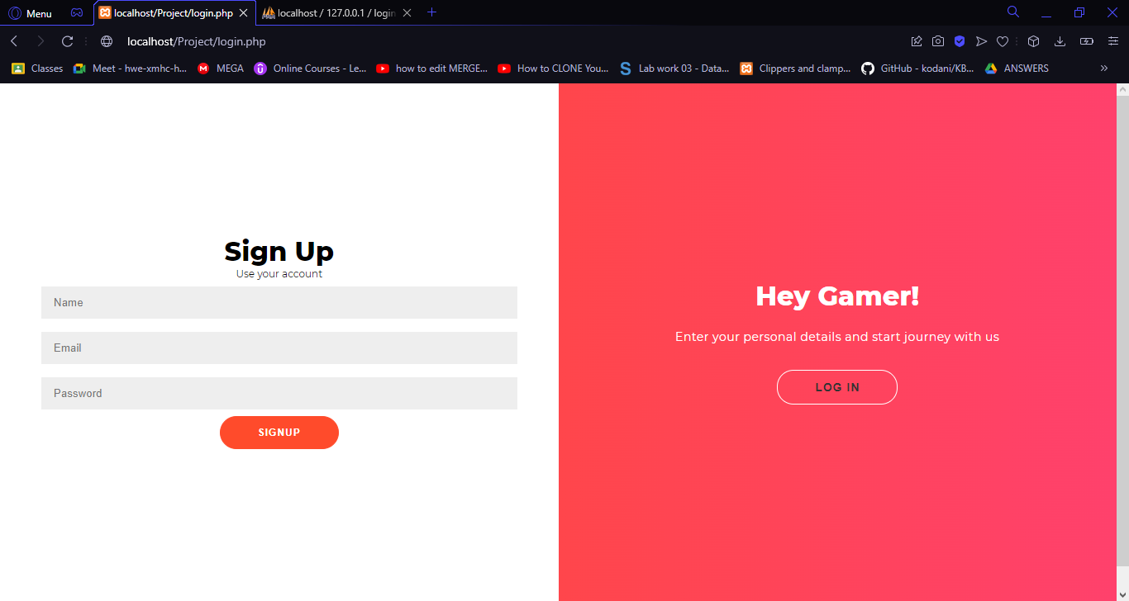

There are already some accounts of our daily users created for logins. Below is the snapshot for the same. To be more precise there are 4 daily users already enjoying our website.

**BACKEND SNAPSHOTS:**

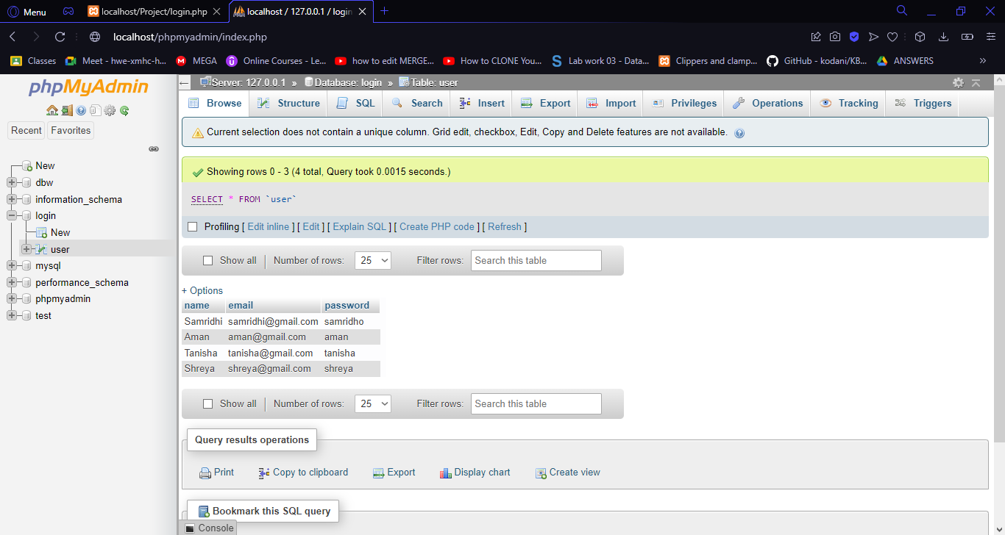

Now if we want to signup for a new account, we can easily signup, and the newly created accounts credentials will be stored in the backend. Illustrated as follows:

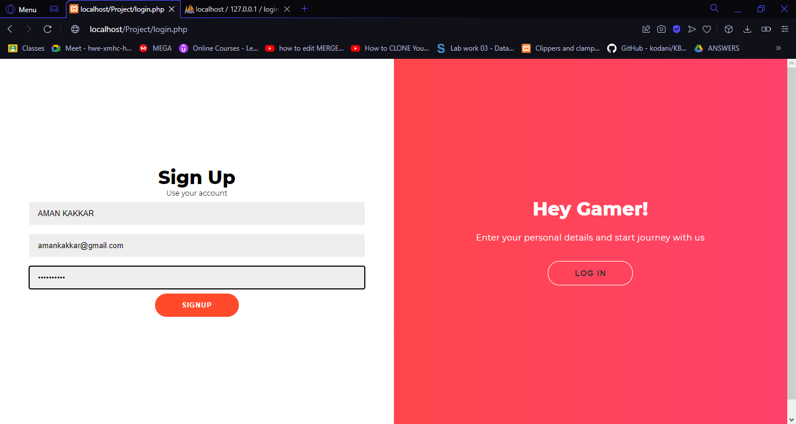

As soon as I click on the signup button below, a popup will come to tell if the account has been created or not. In our case account has been created successfully.

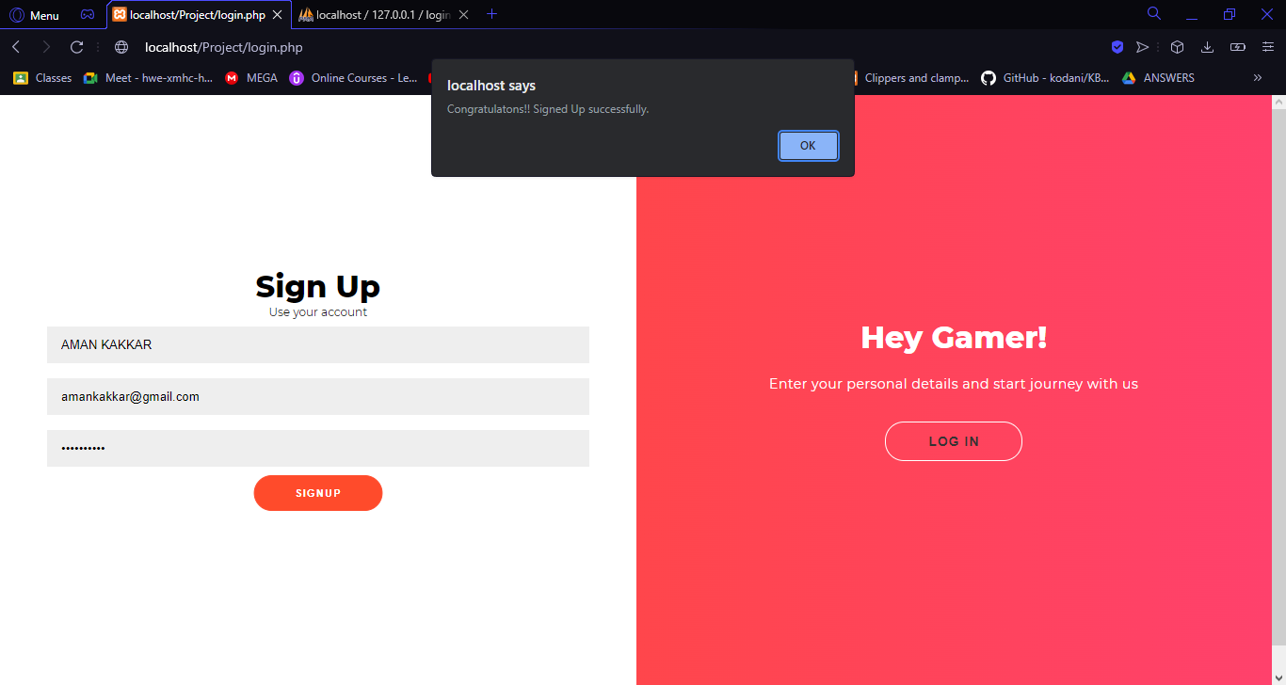

Then a popup will come to tell the users to follow the next step of login to the account through the login button placed just on the right.

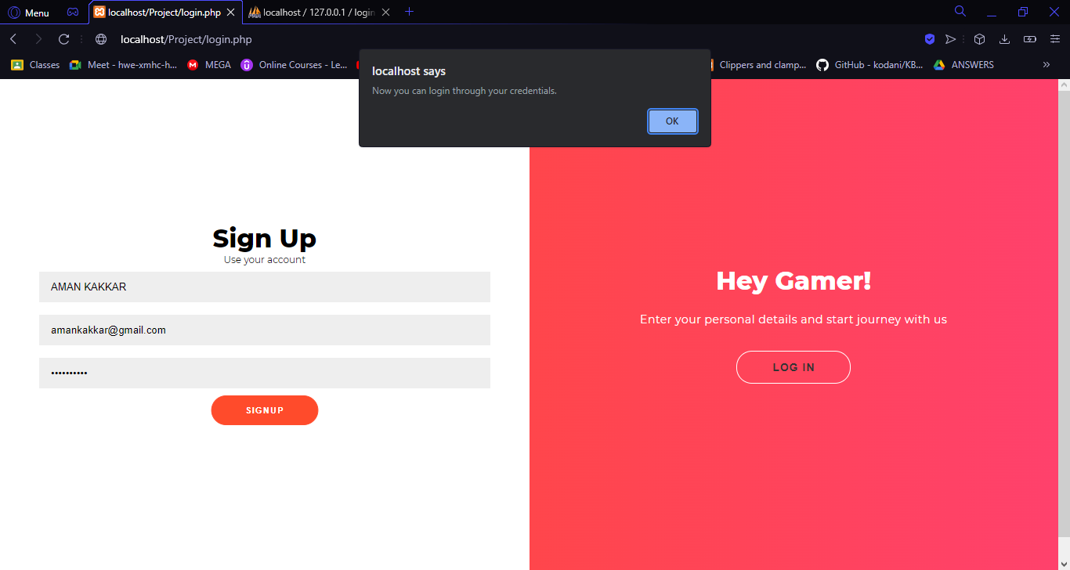

CONGRATULATIONS!!

You have successfully signed up for the Techno- Games. Now you just need to login with your account you just created by clicking on the login button on the right half of the page.

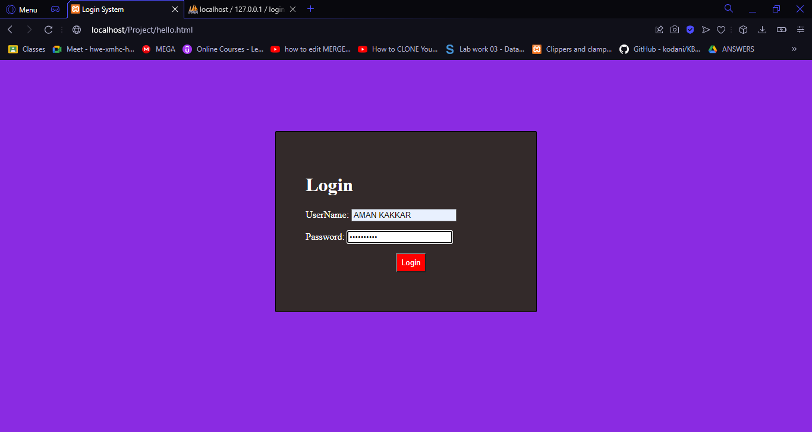

As soon as you click on the login page with the correct credentials, you will be forwarded to the login successful or unsuccessful page. From there you can just click on continue and move to the final destination.

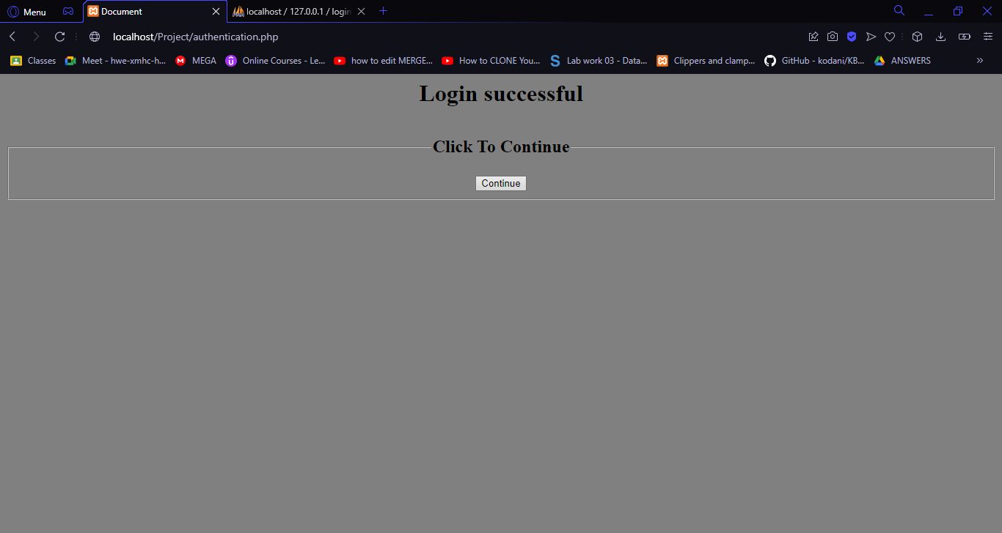

After clicking on continue button, you are directed to the TechnoGames main page where you can enjoy playing your favourite mini games. The interface is as awesome as you expected it to be. There are 2 buttons on the top namely “Users” that allows you to switch accounts, whereas second one is “LogOut” which allows you to go back to the signup page.

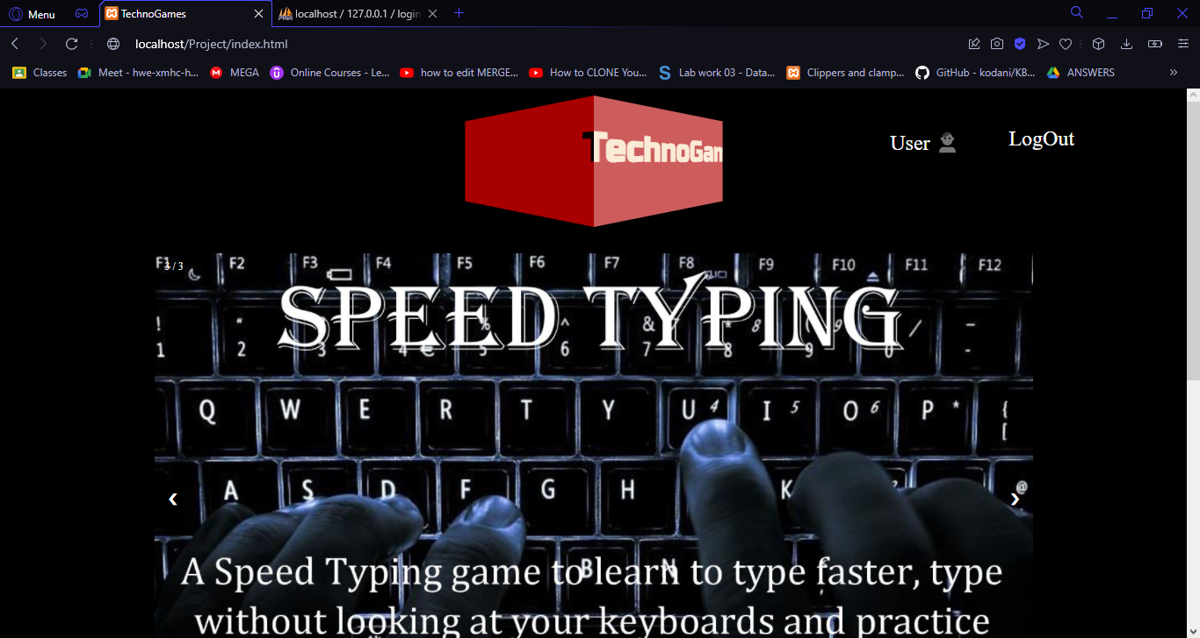

A description of each game is given with exciting interfaces.

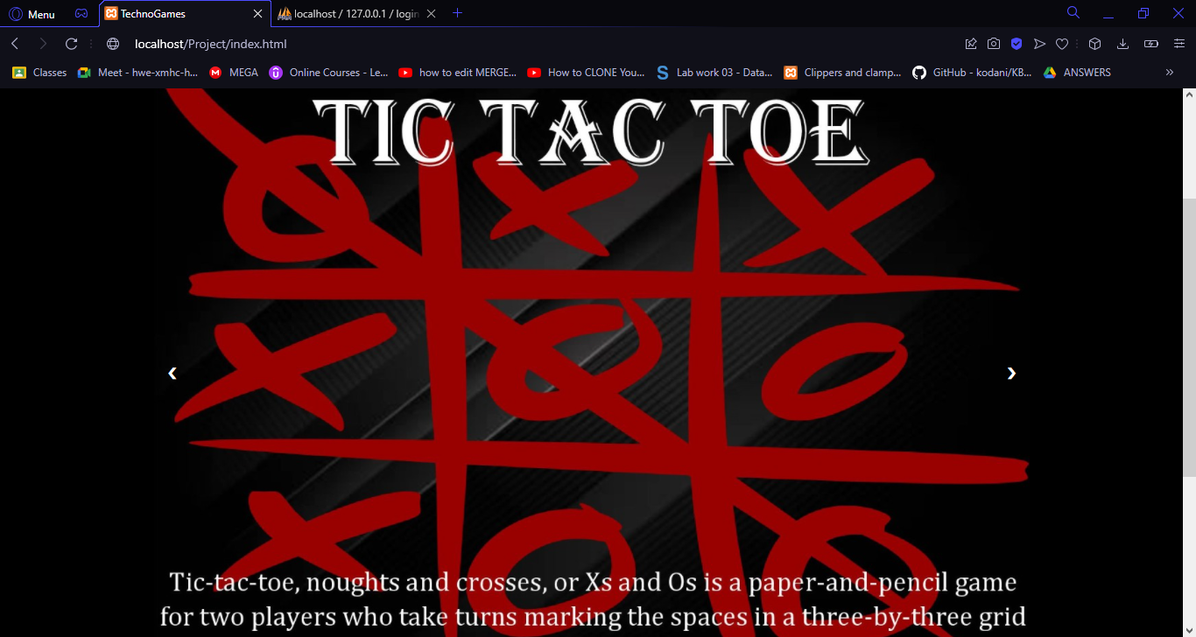

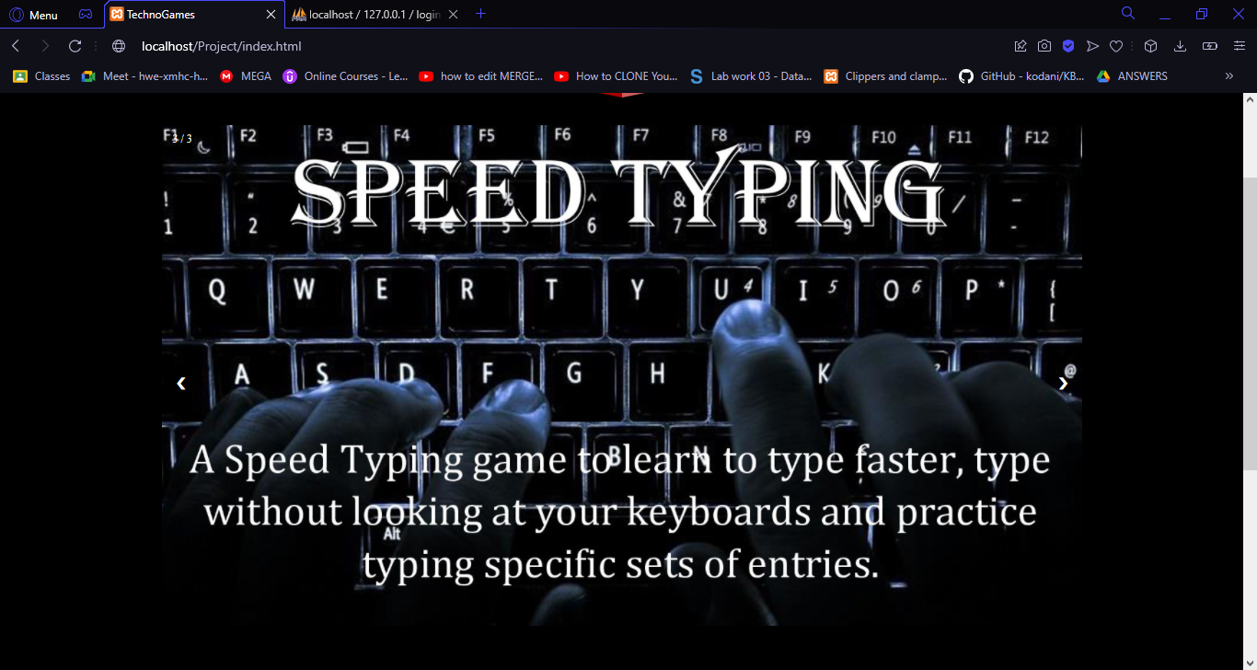

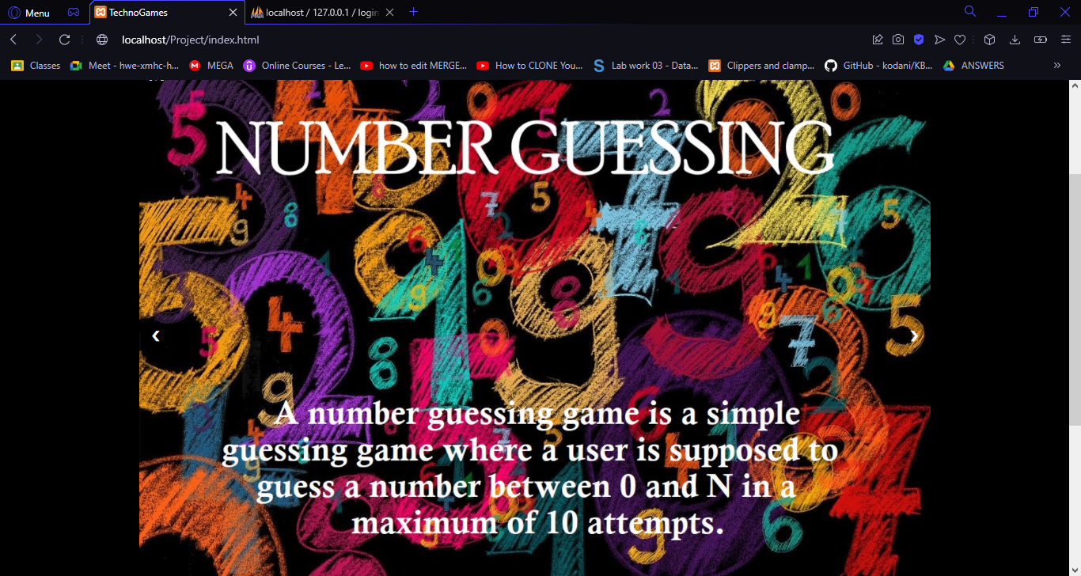

There are links provided below for each game that you want to play. Just hover over them and boom here you go.

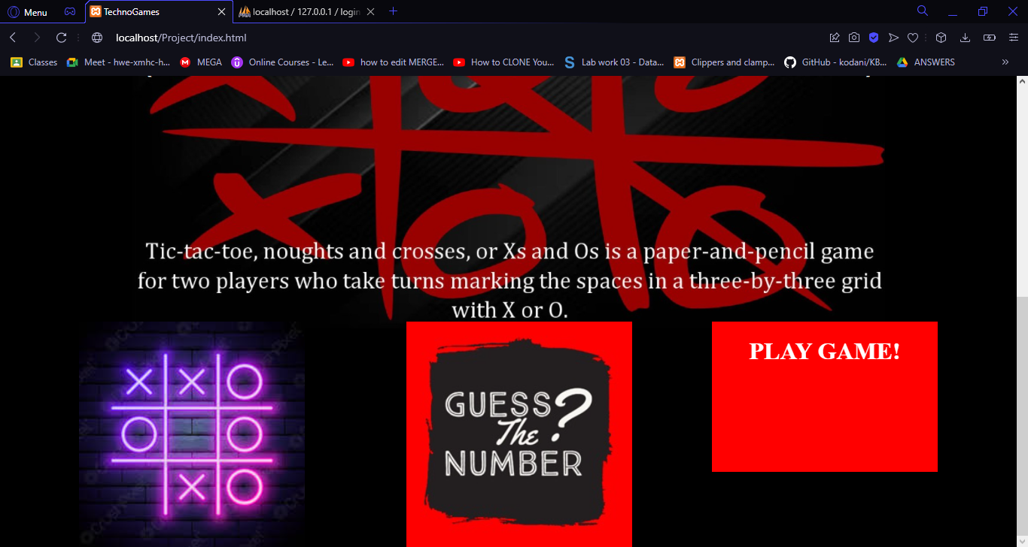

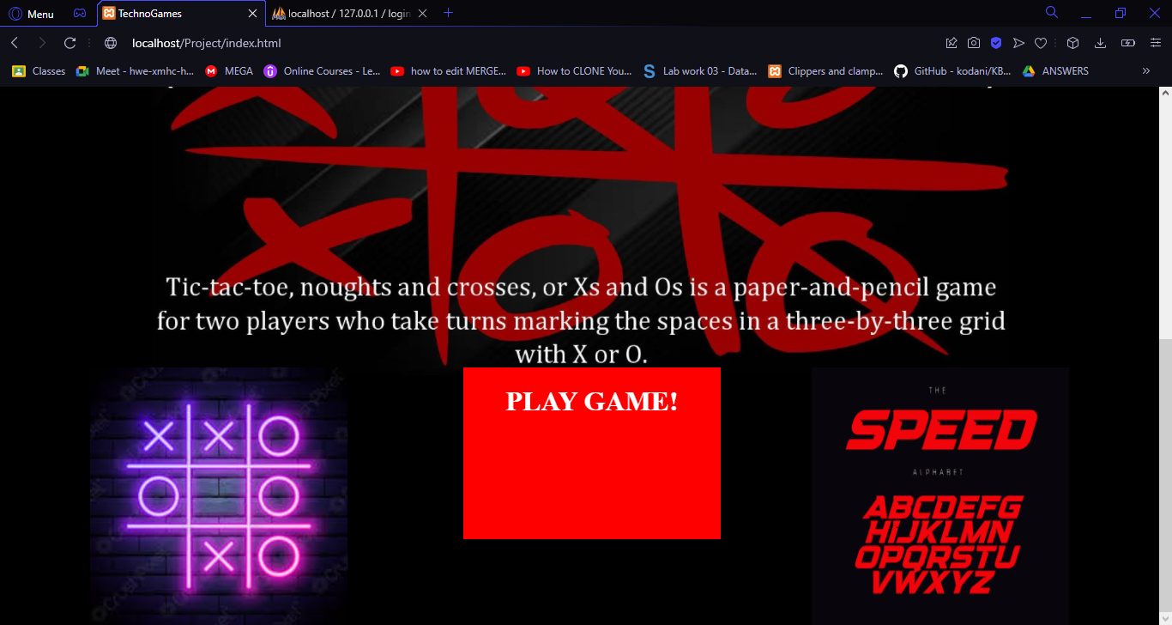

**Illustrating Tic Tac Toe:**

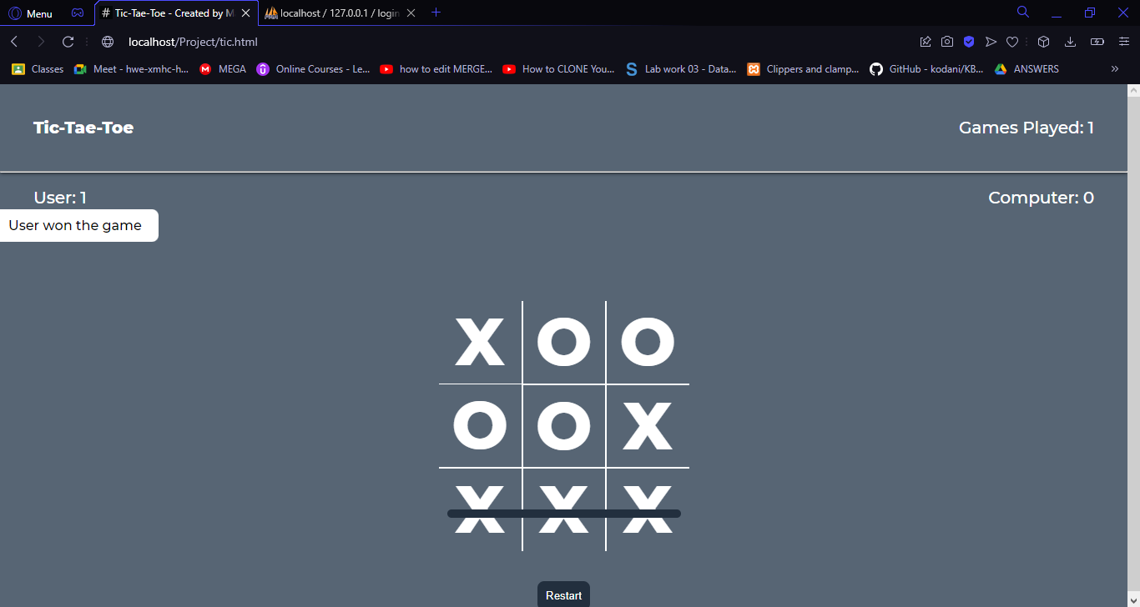

User can play as many games with computer as he wants. The score card displays users winning on the left and computer’s winnings on the right. Total games played are also displayed at the top. A message from the left is popped after each game is finished telling who’s the winner. A restart button is also provided below so that no user shall face difficulty in restarting the game again and again.

**Illustrating Guess My Number:**

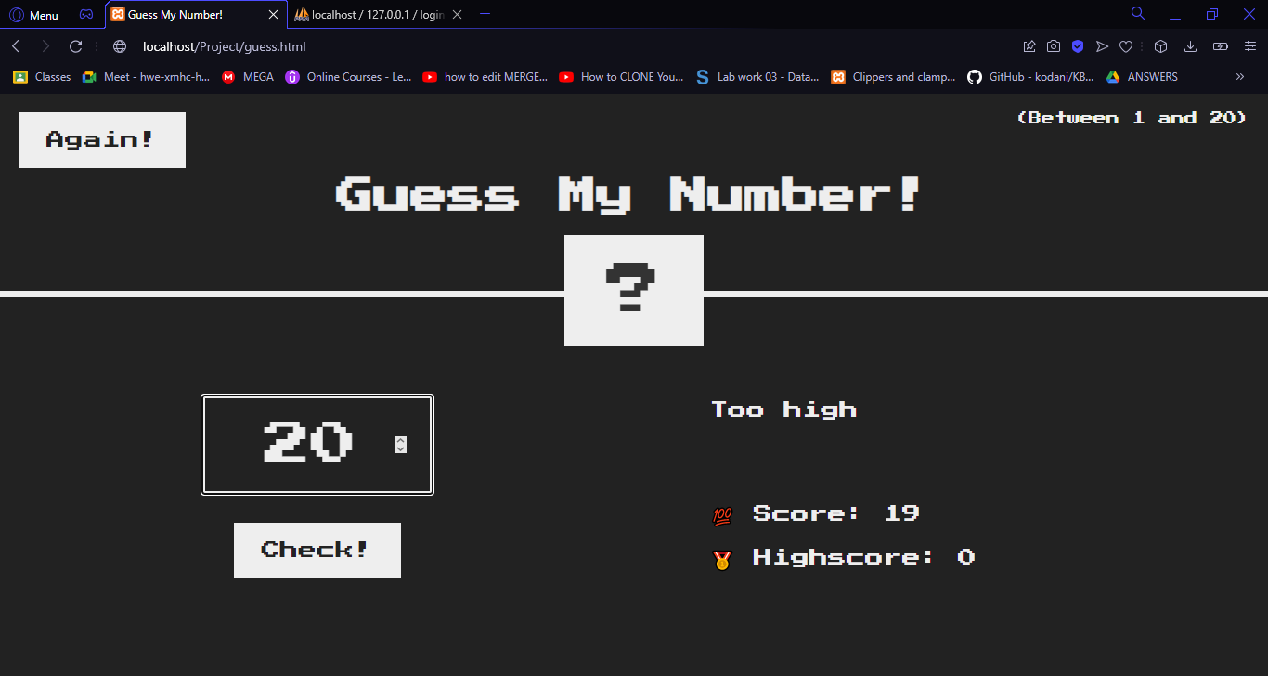

This is one of the favourite games of our users as it is very hard to predict which number is there hidden at the back. We have given 20 guesses for guessing the number correctly and the numbers lies between 1 and 20. This game also can be played any number of times. Highest scores and total scores are also shown below. For making the game more interesting, the user gets hints of ‘too high’ or ‘too low’ for making right choices asap. As soon as the user guesses the right number the lights gets on showing the happy moments.

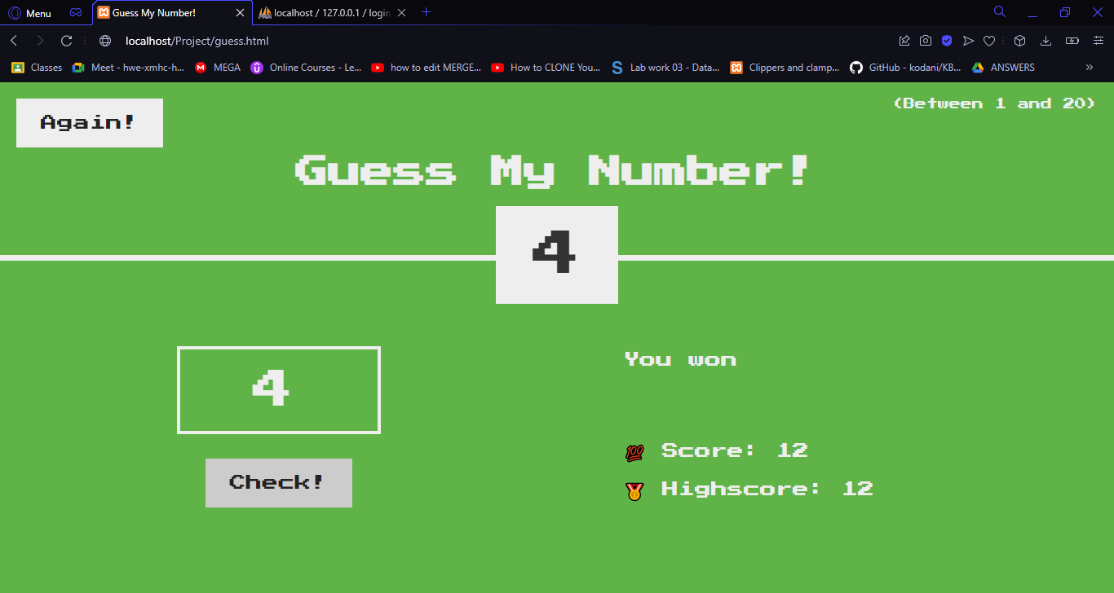

**Illustrating Speed Typing:**

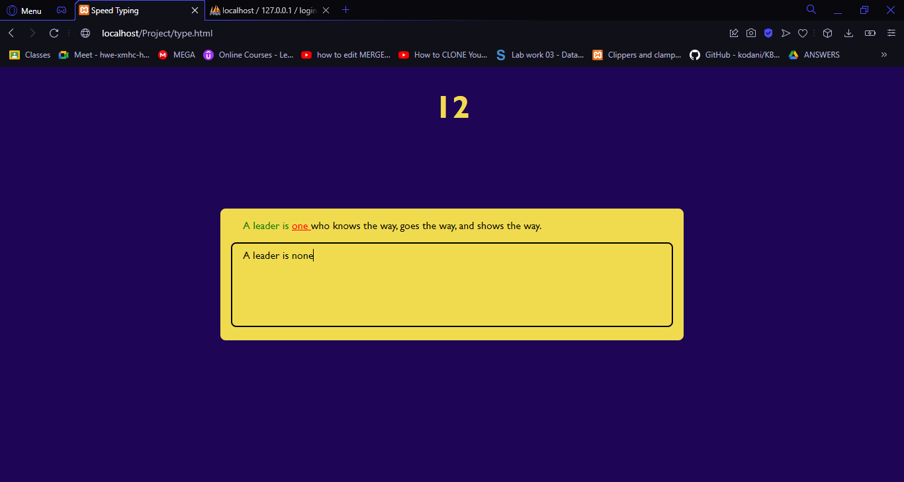

A timer is provided on the top to tell from how many seconds you are typing. Till the time you are typing correct text it will be in green color. As soon as you type any wrong text the text color will be changed to red automatically indicating you the wrong words. This game is fun and can help one to increase the typing speed very efficiently.

CONCLUSION AND FUTURE WORK:

We aimed at creating an Indian multi gaming website in which we can play multiple games. Among all the three games, tic tac toe is a multiplayer game while number guessing and speed typing are single player game. Our application will play an important role for the advancement of apps that are made for entertainment purposes.

We will also try to make it more secure and user friendly on the basis of the feedbacks sent to us.

References

* <https://www.w3schools.com/whatis/>
* <https://www.geeksforgeeks.org/web-development/>
* <https://www.youtube.com/watch?v=R-7eQIHRszQ>
* Assignments given in the lab